**Software Development Capstone Project SE-133**

**Online Shopping System**

**Student declaration:**

I declare that - I understand what is mean by plagiarism. The implication of plagiarism has been explained to me by my institution. This assignment is all my own work and I have acknowledged any use of the published and unpublished works of other people.

**Student’s signature:** Abu Kowshir Bitto

**Date**: 24-09-2018

|  |  |
| --- | --- |
| Student Full Name | Abu Kowshir Bitto |
| Student ID | 181-35-2379 |
| Submission Date | 24-09-2018 |
| Class Code / Section | SE133/C |
| Lecturer’s Name | Md.Sohel Arman |
| Total number of pages including this cover page | 15 |

Page -1

**CONTENTS**

INTRODUCTION…………………………………………………………………….3

CURRENT SYSTEM………………………………………………………………….4

PR0BLEMS AND LIMITATION………………………………………………….5

PROPOSED NEW SYSTEM……………………………………………………….6

BENEFIT OF NEW SYSTEM………………………………………………………7

SYSTEM SPECIFICATION/ FUNCTION MODULES…………………….8

INPUT AND OUTPUT SPECIFICATION………………………………………9

HARDWARE AND SOFTWARE MAINTENANCE………………………10

EXERCUTING SUMMARY………………………………………………………11

PROJECT WORK DESCRIPTION & DURATION……………………….15

Page-2

**INTRODUCTION**

We got our independence from Pakistan in 1971. From there our country going for a develop country. For making a develop country we should make our country digital. Day by day our country going throw for digital country. But some current system is not digital. It’s very high time to make our country digital.

We can use our valuable time for marketing like electronic device, cloth etc. Everyone know that “Time and tide wait for none”.

In this project we can make an online marketing system. That will save our valuable time. It’s also makes our country digital and developing country. The project arrangement is complete and reliable for all people who can use this. This will make many of the users to have less time wastage not only the users but the workers will find it’s easier to organize their day to day activities. It’s a simply way for buying and selling. The program will be created with use of a third generation language called C Programming and software named Code blocks.

Page-3

**CURRENT SYSTEM**

People going to a shop market for buying cloth, electronic device. All the market has a limited distance. We find best product for buying. If we don’t find best product or suitable product, then we will go throw other shop. That will waste our time. All our daily operations are performed manually which makes a develop country like slow and complex. Due to these processes, we lose most of our time and makes our body tired.

Now we can use a modern way for marketing that easy for everyone who use this. This system will make them to do their work in a simple and cleared way. This system will be better from current system.

Page-4

**PROBLEMS AND LIMITATION**

**Time Wastage:** For going to a shop and buying a product we can give our valuable time.

**Body Tiredness:** For going one shop to another we make our body tired.

**Huge Capital Required:** Huge amount of capital required to establish supermarket.

**Lack of Personal Attention:** The employees and other staff do not pay adequate care. The customer should bring goods up to counter by themselves to pay bills. The employees do not care for customer.

Page-5

**PROPOSE NEW SYSTEM**

The new arrangement is dependable because it is a programmed program. The system program need a code blocks software program install before it works. In the new system people buy their product in online without wastage valuable time. A simple and easier way for buying their necessary product. They will choose their product in online and order it. This program will allow the customer to buy their product and easier payment method. This program will allow the admin to add product and easier payment method and admin will also see their available stock. The system will make many users to learn how to use computer for their aspect of better life. This will suit the need of most users since the system has been computerized and its new and modern system almost all over the world or developed countries.

Page-6

**BENEFIT OF NEW SYSTEM**

**Better Prices.** Better price is available in online, because the product is direct come from manufacture or seller without middleman involved.

**More Variety.** The choice online is amazing. We can get several brands and products from different sellers in one place.

**Fewer Expenses.** Many times, when we opt for conventional shopping, we tend to spent a lot more than planned. There are other outside expenses like eating, transportation etc. We can it when we buy online.

**Saving Time.** We can save our valuable time because we can buy our product without going anywhere.

Page-7

**SYSTEM SPECIFICATION/ FUNCTION MODULES**

The programming language that will be used in coding this work is C programming language, which can be developed modules of program running, firstly the introduction of the program is displayed and then the main menu which is made up of:

**Administration**: Admin will add product and also see their product stock which are available.

**Customer service**: Customer will buy their necessary product with choosing. They will buy which are available in stock.

**Exit**: If any user going for a break or don’t buy anything or don’t choose anything for buy they will go for exit.

Page-8

**INPUT & OUTPUT SPECIFICATION**

|  |  |  |  |  |
| --- | --- | --- | --- | --- |
| Serial | Item Name | Description | Data Type | Size |
| 1 | Administration | Admin will add product and see product stock | String | 29 |
| 2 | Customer Service | Customer will chose their suitable product | String | 25 |
| 3 | Log In System | Admin will log in for add product & customer for payment. | Integer | 0-50 |
| 4 | Shopping | Customer will buy product. | String | 27 |

Page -9

**HARDWARE & SOFTWARE REQUIREMENT**

**Hardware Requirement**: For the Program to be run the set of computer hardware must be prepared with the following specifications:

1. Core i3 or higher

3. 2GB RAM or higher

4. 10 GB HDD 0r higher Mouse

5. QWERTY keyboard

**Software Requirement**: For the Program to be run the set of the following software must be prepared with the following specifications:

1. The Main Program Code Blocks

2. MS Word or Other Text Editor

3. Borland C++/Turbo C++

Page-10

**EXECUTIVE SUMMARY**

In this proposal I have discuss about the introduction of the system meanwhile the problems faced by the people and I have discussed about my new system that can manage and help the people.

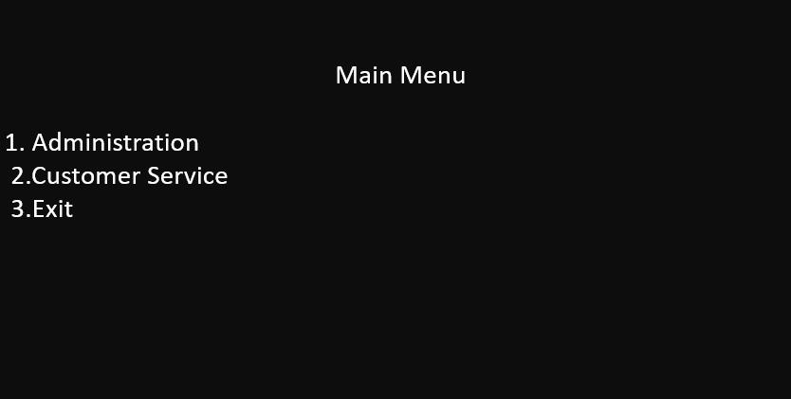

Page-11

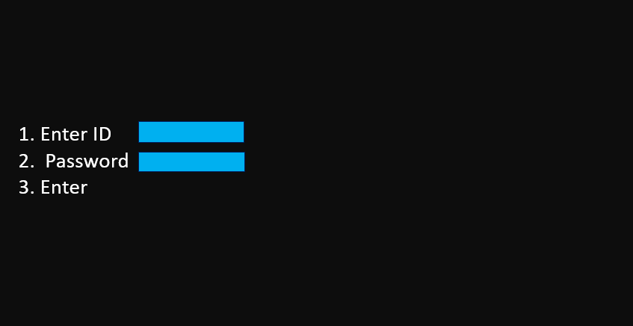

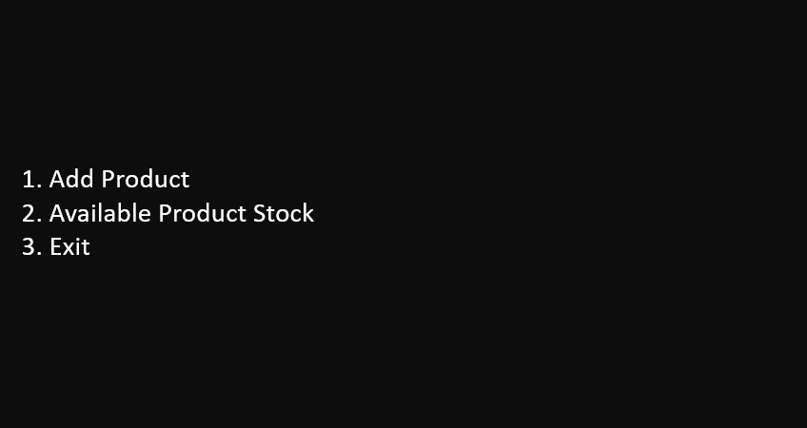

Page-12

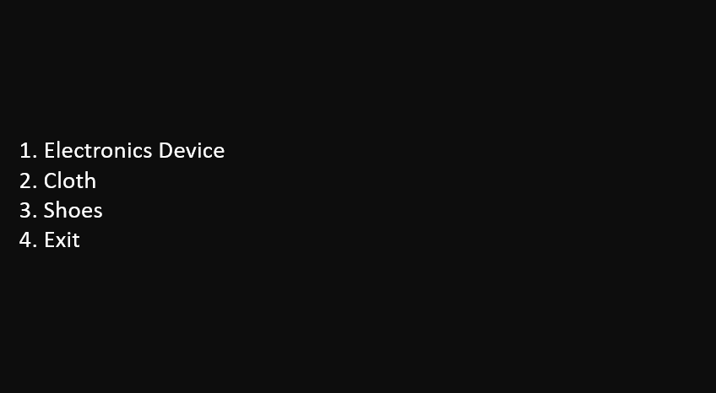

Page-13

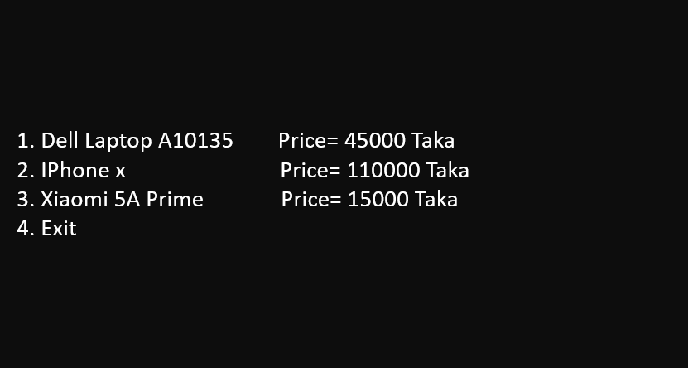

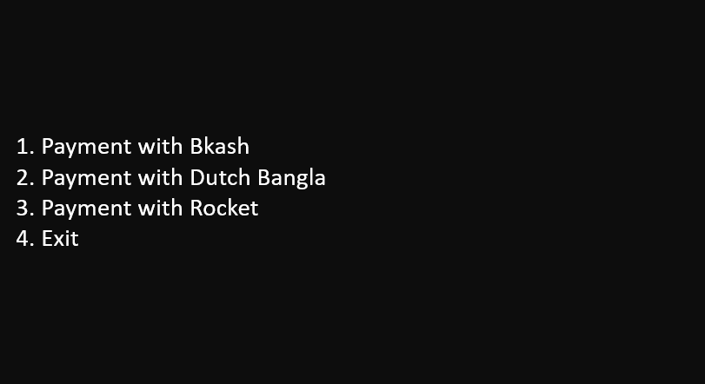

Page-14

|  |  |  |  |  |
| --- | --- | --- | --- | --- |
| Serial | Work description | Start date | End date | Signature |
| 1 |  |  |  |  |
| 2 |  |  |  |  |
| 3 |  |  |  |  |
| 4 |  |  |  |  |
| 5 |  |  |  |  |
| 6 |  |  |  |  |
| 7 |  |  |  |  |
| 8 |  |  |  |  |
| 9 |  |  |  |  |

**PROJECT WORK DESCRIPTION & DURATION**

Page-15